## **Difference between pairs of evaluators normalized to the maximum error**

**Table: error (1 sigma)**

|  |  |  |  |  |  |  |
| --- | --- | --- | --- | --- | --- | --- |
|  | Height(Z)  (mm) | slopeX  (mrad) | slopeY  (mrad) | devZ  (mm) | devSlopeX  (mrad) | devSlopeY  (mrad) |
| ENEA | 0.30 | 0.09 | 0.09 | 0.30 | 0.09 | 0.09 |
| F-ISE | 0.13 | 0.30 | 0.18 | 0.13 | 0.30 | 0.18 |
| DLR | 0.20 | 0.20 | 0.20 | 0.20 | 0.20 | 0.20 |
| NREL | 0.26 | 0.12 | 0.12 | 0.26 | 0.12 | 0.12 |
| SANDIA | 0.20 | 0.08 | 0.08 | 0.20 | 0.08 | 0.08 |

These errors have been used to normalize the differences between pairs of participants by considering the root of their sum square to set the maximum error as 3 times of the obtained value. In the following mean, standard deviation and 2D contour maps got for inner#60 and outer#93 specimens are shown.

Unfortunately the difference are often greater than the experimental error.

As general rule ENEA and DLR seem to be the pair of participants in closer agreement, while NREL and SANDIA are the most deviating with respect to the others.

Note that, especially for the inner specimen, the difference of slopeY follows the modulation of slopeY itself along the surface.

**As further attempt, since version 10.0, RRcomparator includes the possibility of computing *ex novo* the z (height) values by means of 2D-integration of the slopes data provided by each participants, starting from the attaching point P2 (the master one). With this new option, followed by the software realignment, except NREL, the agreement is generally better, especially for the mean value.**

**Difference normalized to 3 sigma for inner#60 with “SW realignment by devZ_ideal”**

Inner#60 Height (z)

|  |  |  |  |  |
| --- | --- | --- | --- | --- |
|  | F-ISE | DLR | NREL | SANDIA |
| ENEA | 0.05 ± 0.22 | -0.04 ± 0.08 | 0.00 ± 0.26 | 0.13 ± 0.36 |
| F-ISE |  | -0.14 ± 0.37 | -0.09 ± 0.50 | 0.11 ± 0.51 |
| DLR |  |  | 0.05 ± 0.33 | 0.21 ± 0.50 |
| NREL |  |  |  | 0.13 ± 0.45 |

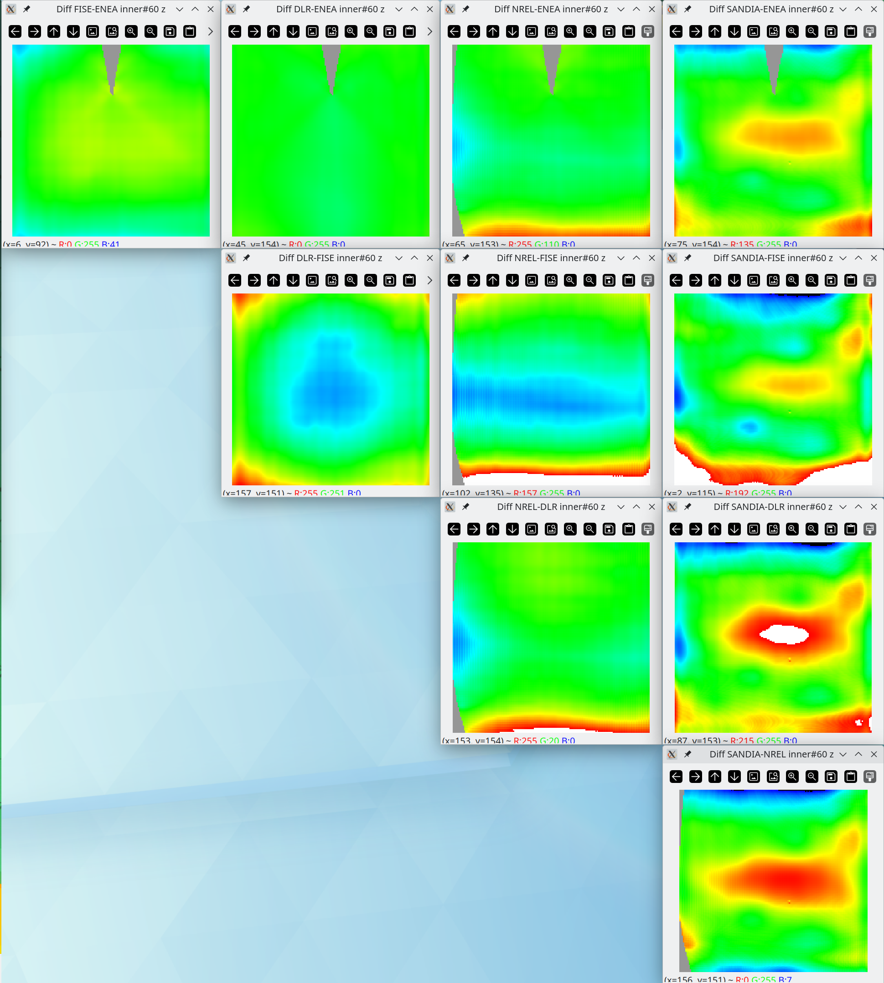

**Difference normalized to 3 sigma for inner#60 with “SW realignment by devZ_ideal”**

Inner#60 SlopeX

|  |  |  |  |  |
| --- | --- | --- | --- | --- |
|  | F-ISE | DLR | NREL | SANDIA |
| ENEA | 0.01 ± 0.65 | 0.09 ± 0.31 | -1.38 ± 4.16 | -2.32 ± 2.86 |
| F-ISE |  | 0.02 ± 0.52 | -0.65 ± 1.75 | -0.89 ± 1.31 |
| DLR |  |  | -0.95 ± 2.62 | -1.41 ± 1.77 |
| NREL |  |  |  | -0.51 ± 4.75 |

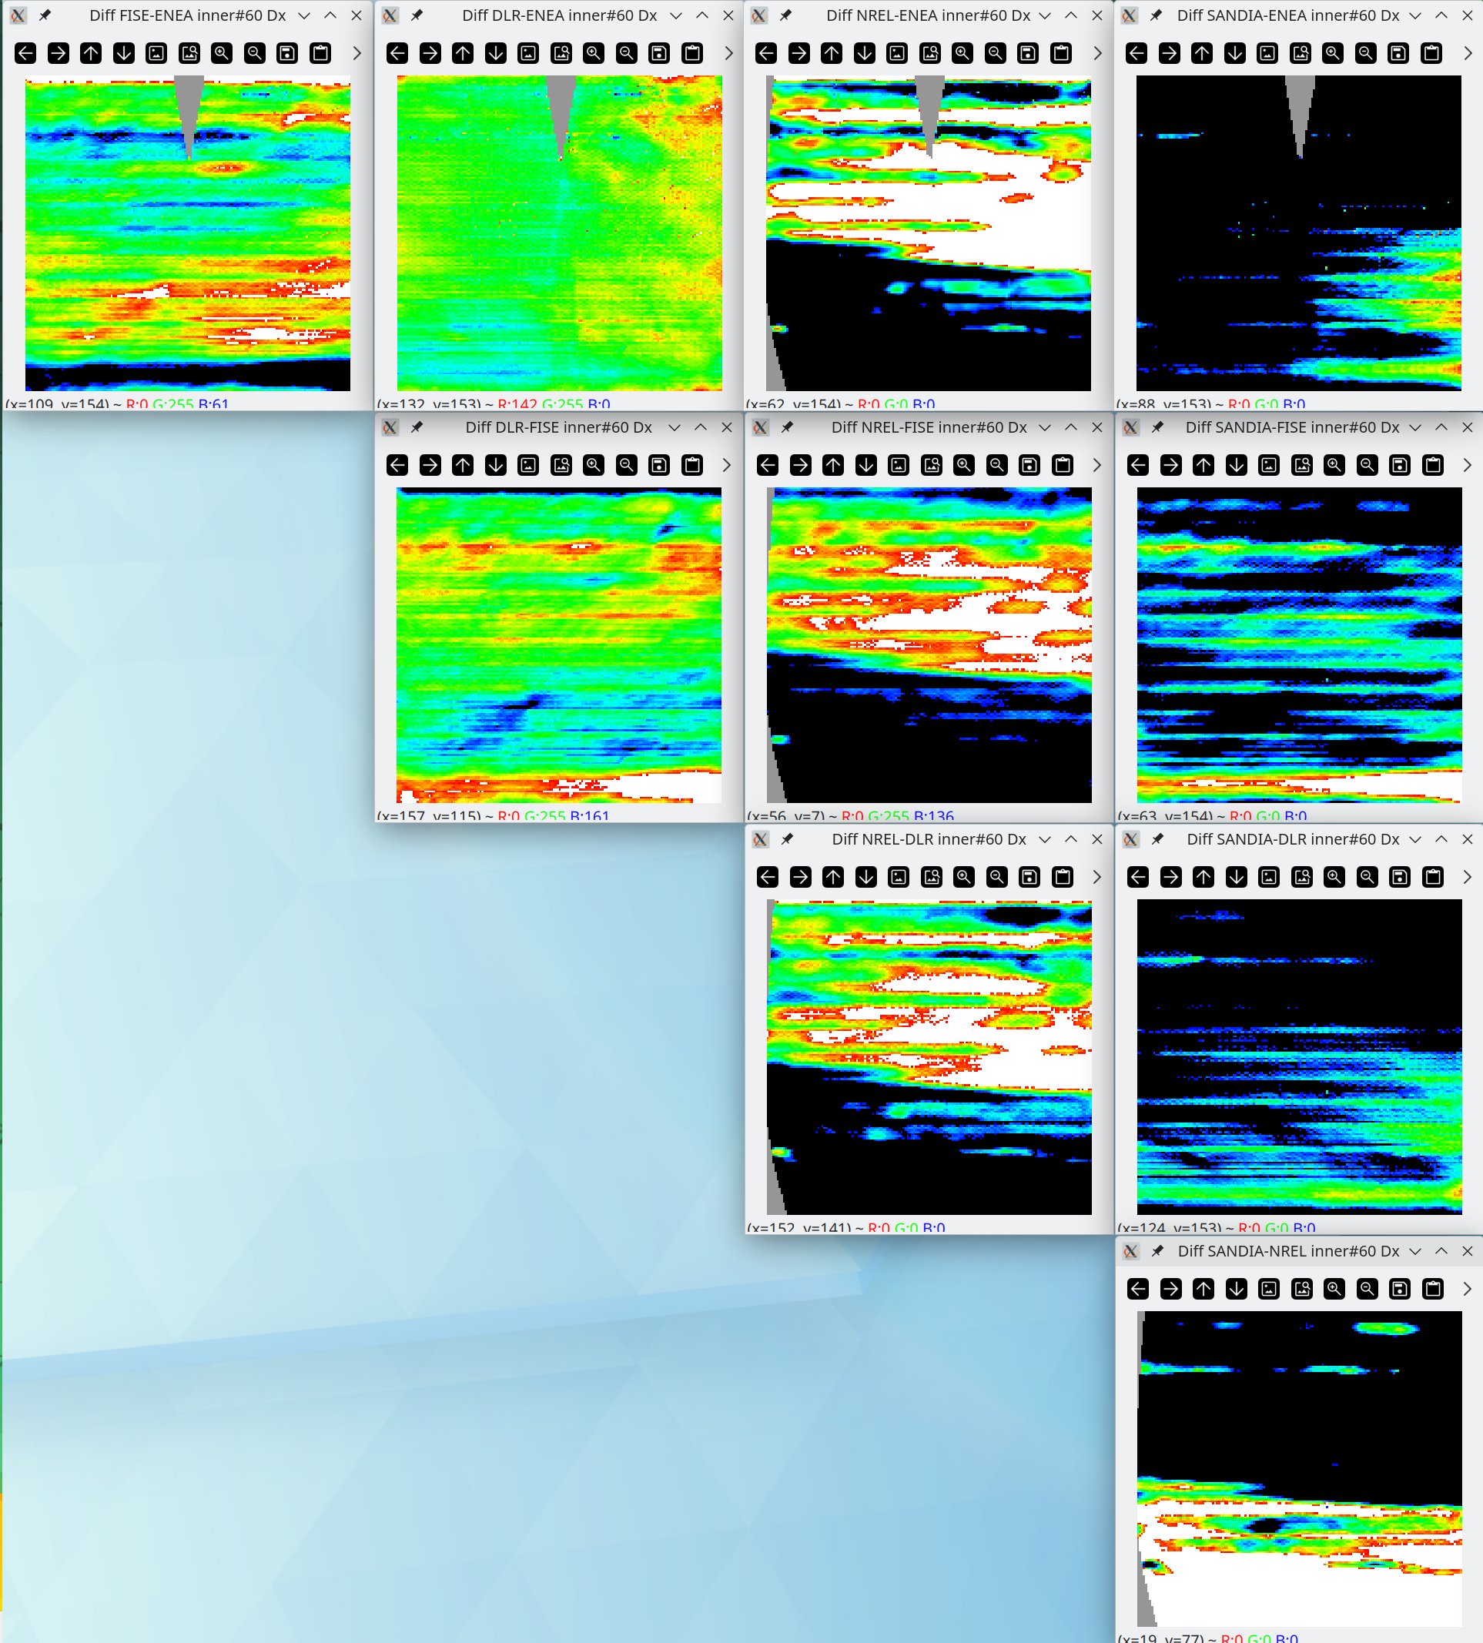

**Difference normalized to 3 sigma for inner#60 with “SW realignment by devZ_ideal”**

Inner#60 SlopeY

|  |  |  |  |  |
| --- | --- | --- | --- | --- |
|  | F-ISE | DLR | NREL | SANDIA |
| ENEA | -0.06 ± 1.22 | -0.20 ± 0.89 | -0.64 ± 1.71 | -0.76 ± 1.33 |
| F-ISE |  | -0.08 ± 1.42 | -0.27 ± 1.46 | -0.45 ± 1.43 |
| DLR |  |  | -0.25 ± 1.08 | -0.23 ± 0.95 |
| NREL |  |  |  | 0.07 ± 1.82 |

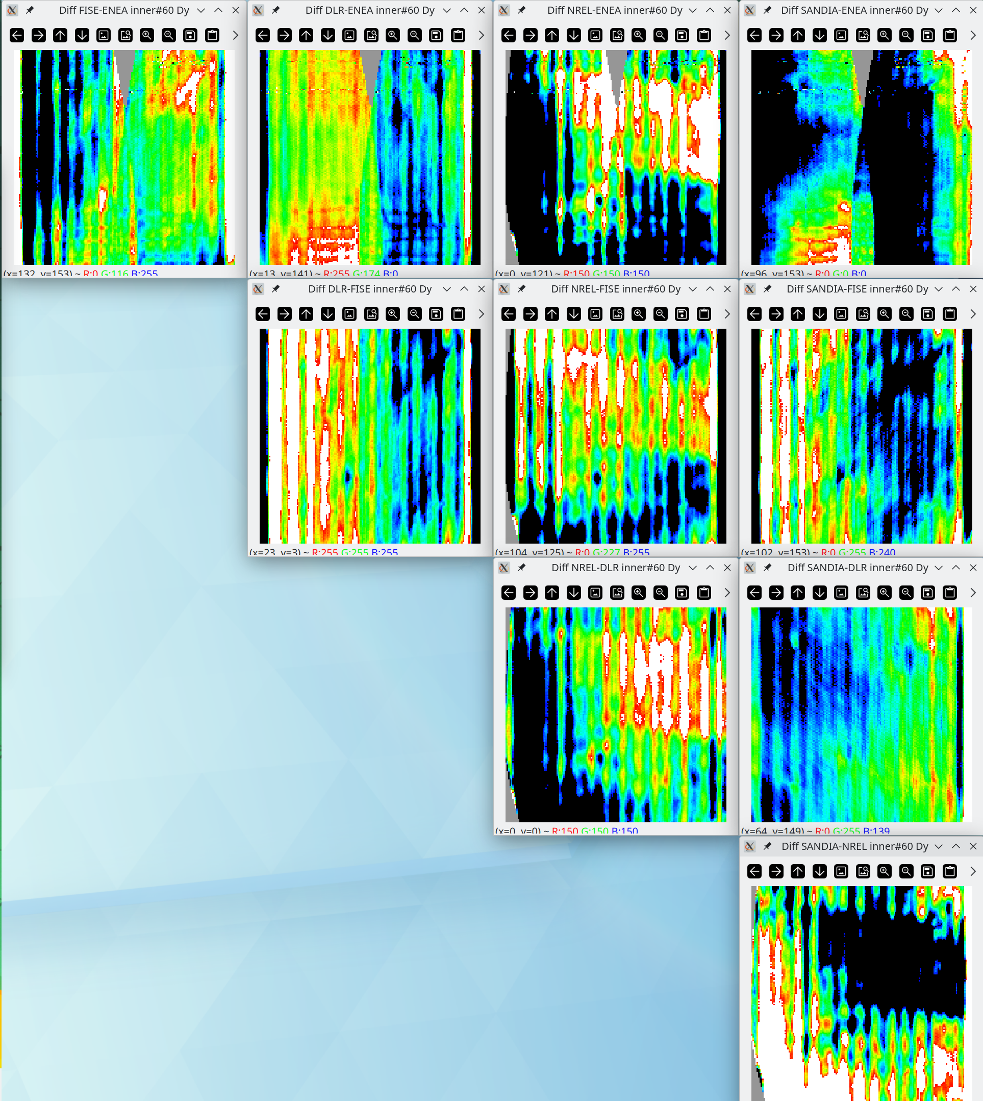

**Difference normalized to 3 sigma for outer#93 with “SW realignment by devZ_ideal”**

Outer#93 Height (z)

|  |  |  |  |  |
| --- | --- | --- | --- | --- |
|  | F-ISE | DLR | NREL | SANDIA |
| ENEA | -0.02 ± 0.08 | -0.06 ± 0.15 | -0.09 ± 0.21 | -0.09 ± 0.30 |
| F-ISE |  | -0.07 ± 0.28 | -0.10 ± 0.27 | -0.10 ± 0.44 |
| DLR |  |  | -0.04 ± 0.26 | -0.04 ± 0.43 |
| NREL |  |  |  | 0.00 ± 0.25 |

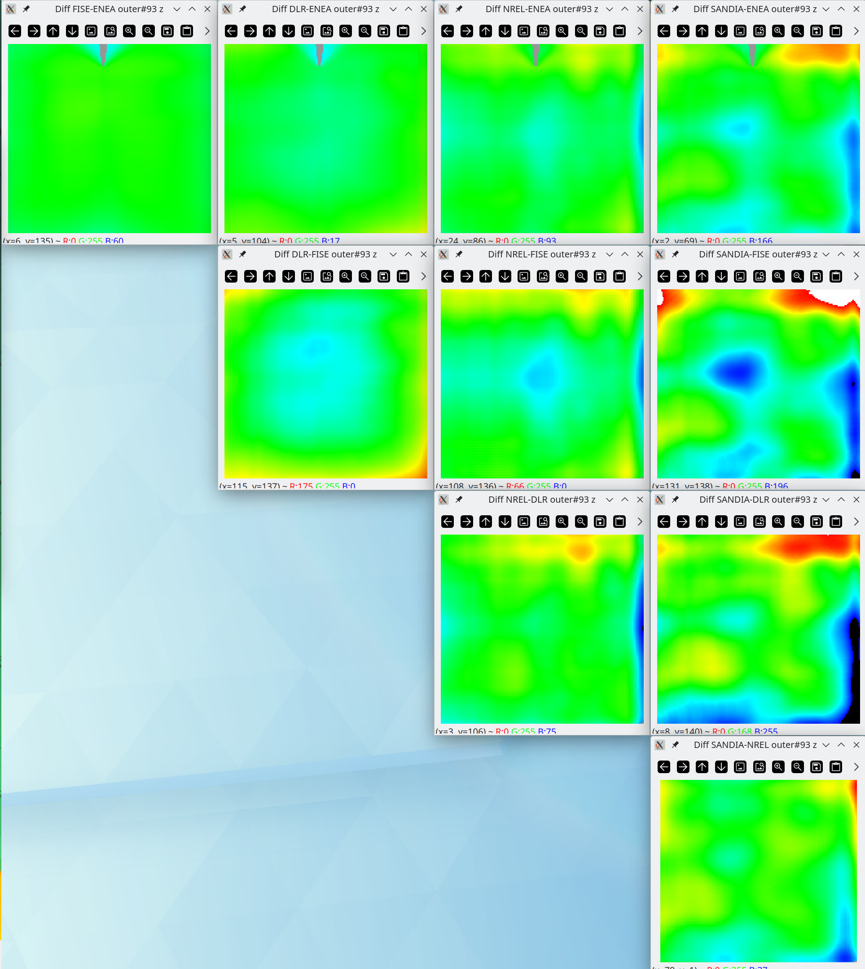

**Difference normalized to 3 sigma for outer#93 with “SW realignment by devZ_ideal”**

Outer#93 SlopeX

|  |  |  |  |  |
| --- | --- | --- | --- | --- |
|  | F-ISE | DLR | NREL | SANDIA |
| ENEA | 0.03 ± 0.27 | 0.01 ± 0.92 | 0.77 ± 2.47 | 1.61 ± 1.99 |
| F-ISE |  | 0.00 ± 0.58 | 0.29 ± 1.02 | 0.60 ± 0.79 |
| DLR |  |  | 0.50 ± 1.45 | 0.88 ± 1.06 |
| NREL |  |  |  | 0.54 ± 2.35 |

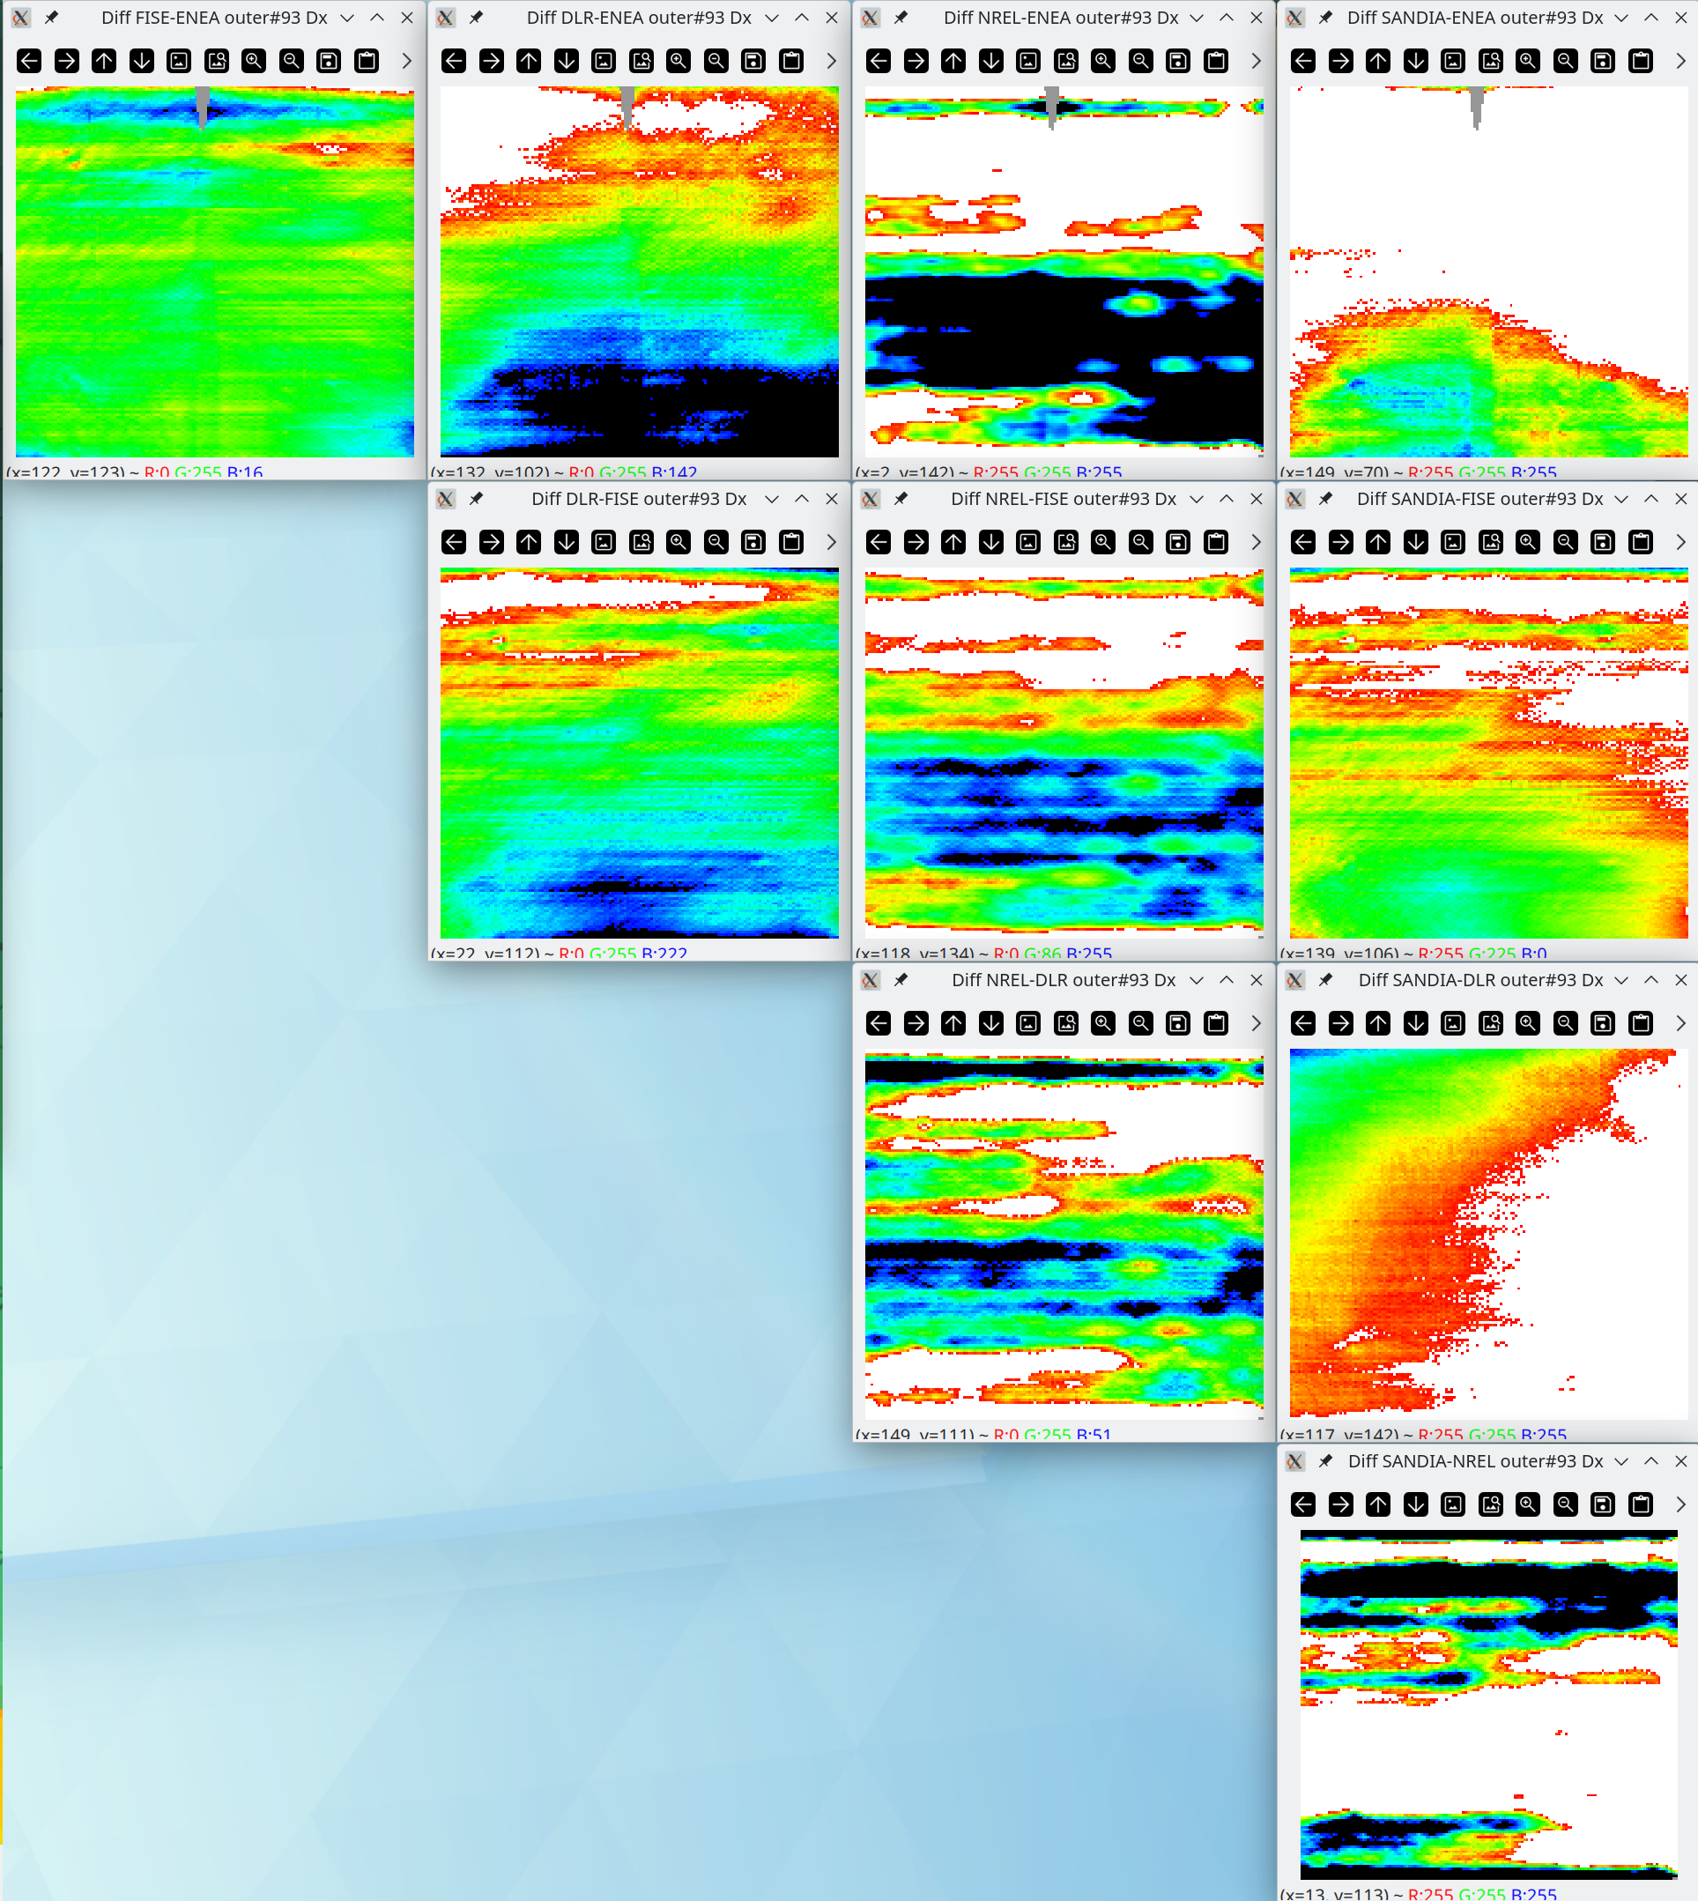

**Difference normalized to 3 sigma for outer#93 with “SW realignment by devZ_ideal”**

Outer#93 SlopeY

|  |  |  |  |  |
| --- | --- | --- | --- | --- |
|  | F-ISE | DLR | NREL | SANDIA |
| ENEA | 0.06 ± 0.78 | -0.07 ± 0.66 | 0.39 ± 3.73 | 0.42 ± 1.31 |
| F-ISE |  | -0.07 ± 0.85 | 0.21 ± 2.31 | 0.18 ± 1.09 |
| DLR |  |  | 0.28 ± 2.53 | 0.29 ± 0.83 |
| NREL |  |  |  | 0.00 ± 3.44 |

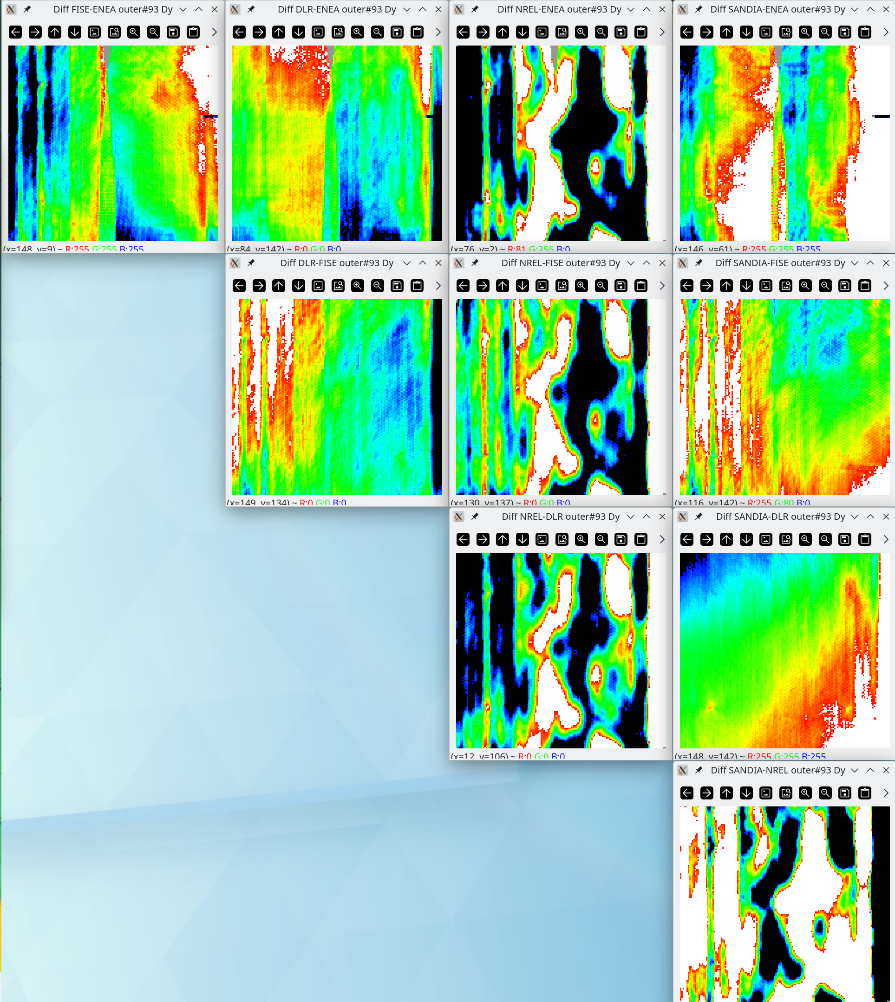

**Difference normalized to 3 sigma for inner#60**

**with internal “2D integration” and “SW realignment by devZ_ideal” options**

Inner#60 Height (z)

|  |  |  |  |  |
| --- | --- | --- | --- | --- |
|  | F-ISE | DLR | NREL | SANDIA |
| ENEA | 0.06 ± 0.13 | -0.05 ± 0.09 | 0.00 ± 0.32 | -0.02 ± 0.10 |
| F-ISE |  | -0.17 ± 0.28 | -0.10 ± 0.42 | -0.12 ± 0.21 |
| DLR |  |  | 0.07 ± 0.40 | 0.03 ± 0.15 |
| NREL |  |  |  | -0.04 ± 0.44 |

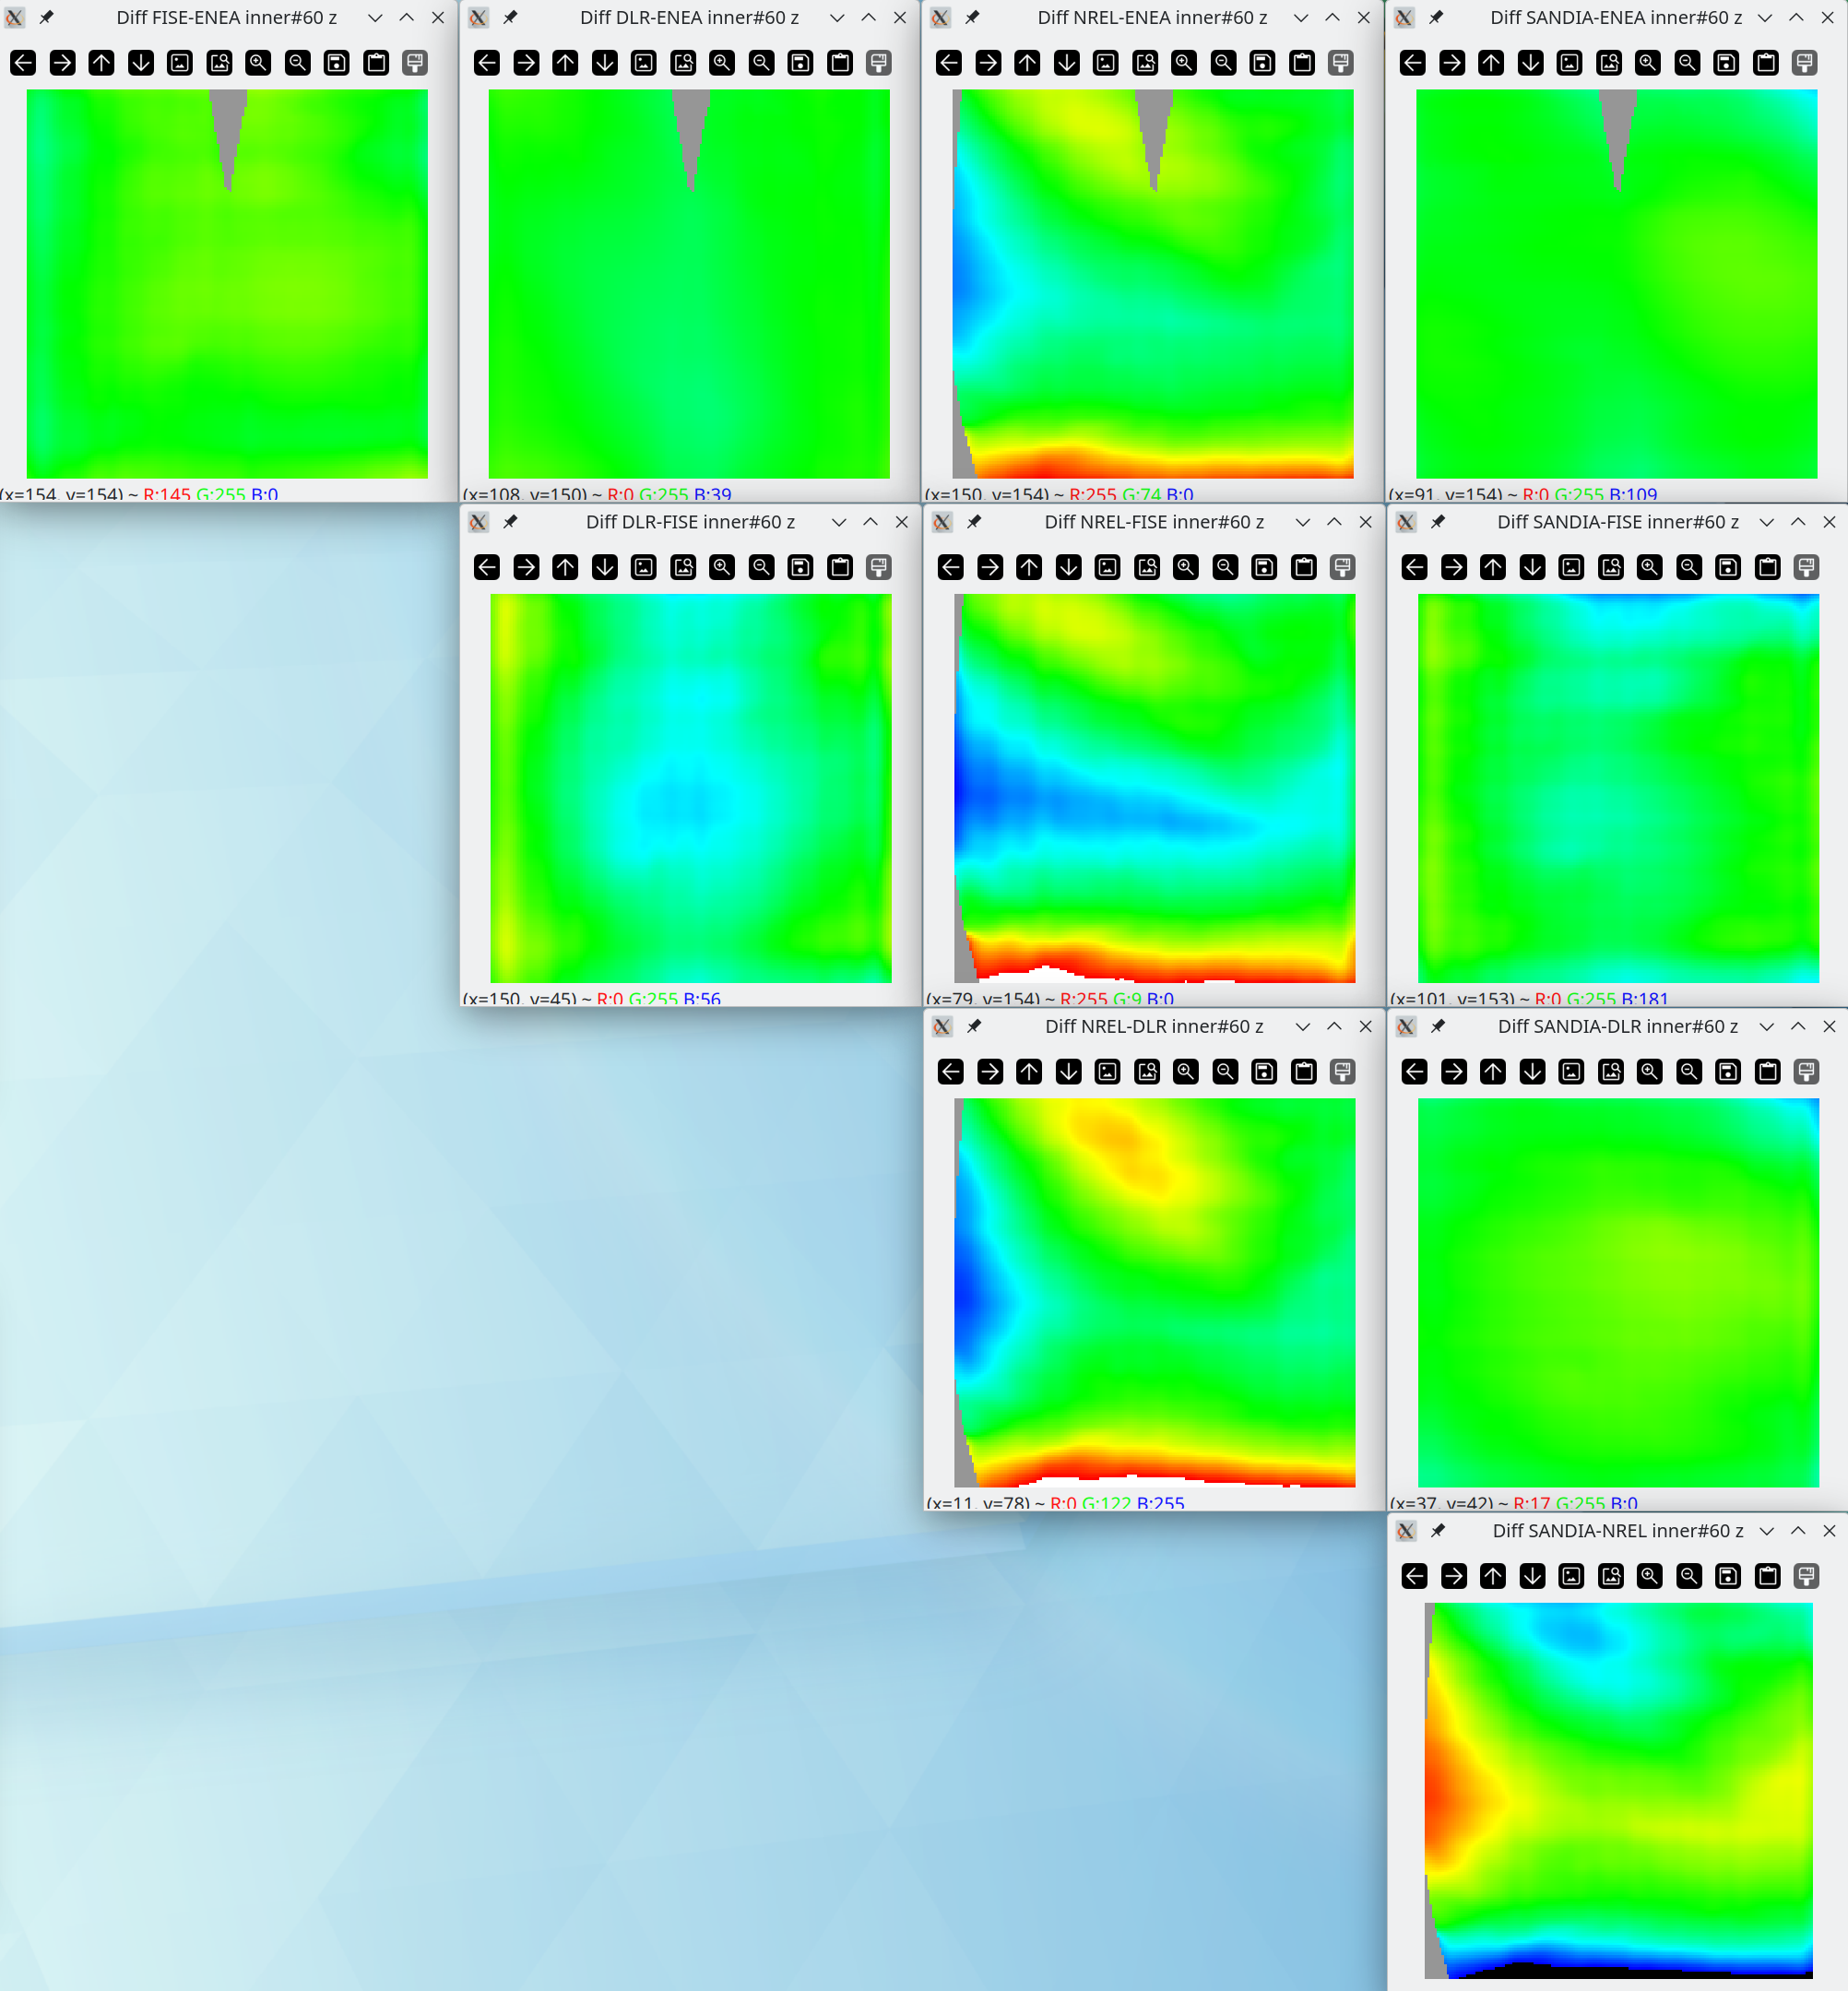

**Difference normalized to 3 sigma for inner#60**

**with internal “2D integration” and “SW realignment by devZ_ideal” options**

Inner#60 SlopeX

|  |  |  |  |  |
| --- | --- | --- | --- | --- |
|  | F-ISE | DLR | NREL | SANDIA |
| ENEA | -0.02 ± 0.65 | -0.05 ± 0.26 | -2.29 ± 4.55 | -0.37 ± 1.71 |
| F-ISE |  | -0.03 ± 0.52 | -1.04 ± 1.94 | -0.09 ± 0.98 |
| DLR |  |  | -1.40 ± 2.83 | -0.17 ± 1.09 |
| NREL |  |  |  | 2.05 ± 5.20 |

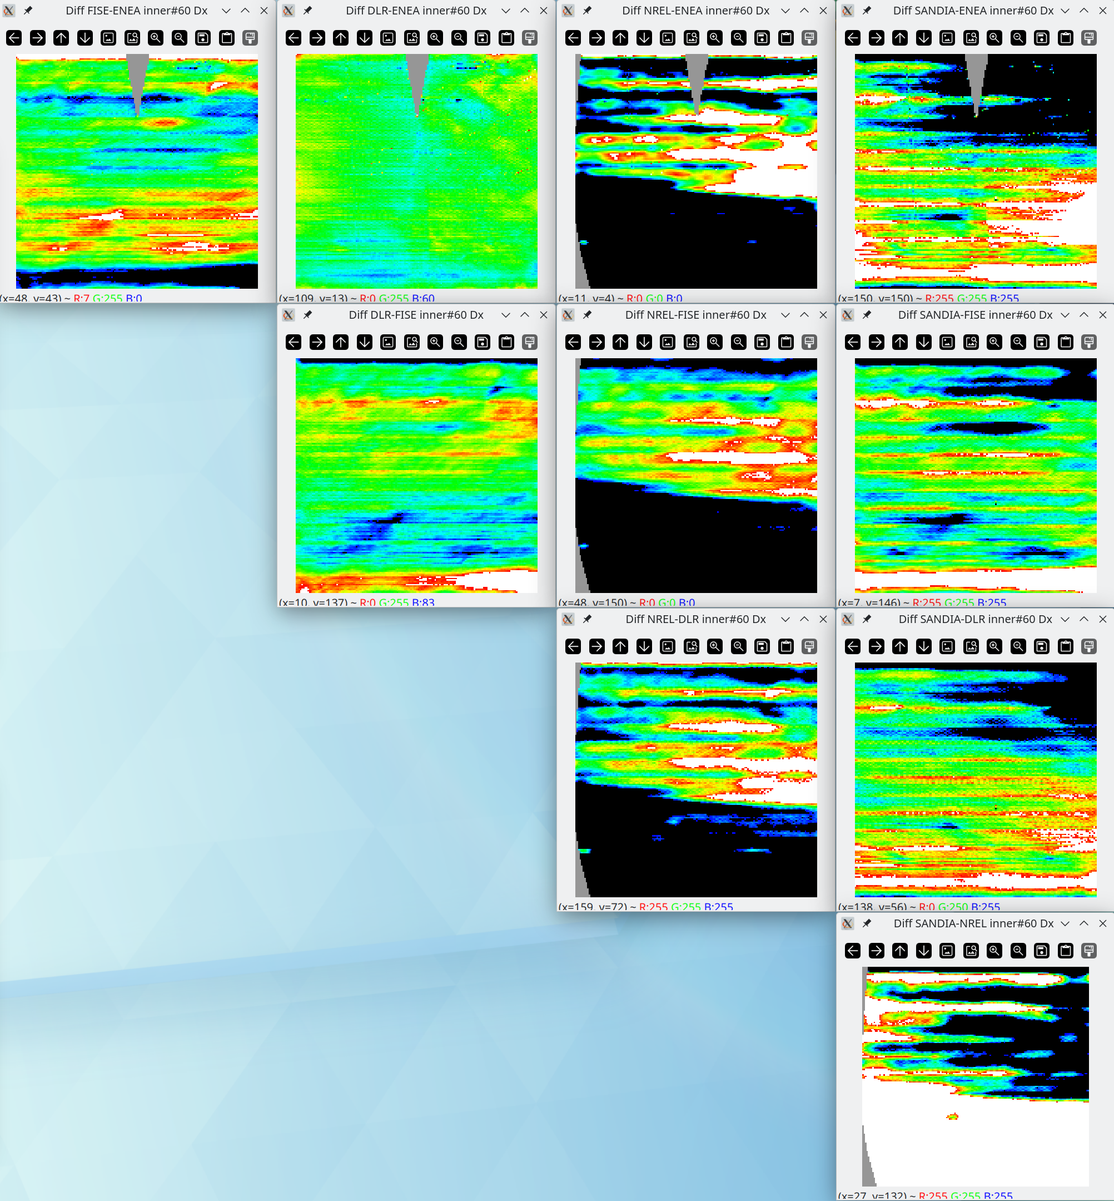

**Difference normalized to 3 sigma for inner#60**

**with internal “2D integration” and “SW realignment by devZ_ideal” options**

Inner#60 SlopeY

|  |  |  |  |  |
| --- | --- | --- | --- | --- |
|  | F-ISE | DLR | NREL | SANDIA |
| ENEA | 0.17 ± 1.24 | 0.04 ± 0.88 | 0.23 ± 1.60 | 0.19 ± 1.14 |
| F-ISE |  | -0.06 ± 1.41 | 0.12 ± 1.41 | -0.09 ± 1.36 |
| DLR |  |  | 0.08 ± 1.02 | 0.06 ± 0.92 |
| NREL |  |  |  | -0.03 ± 1.70 |

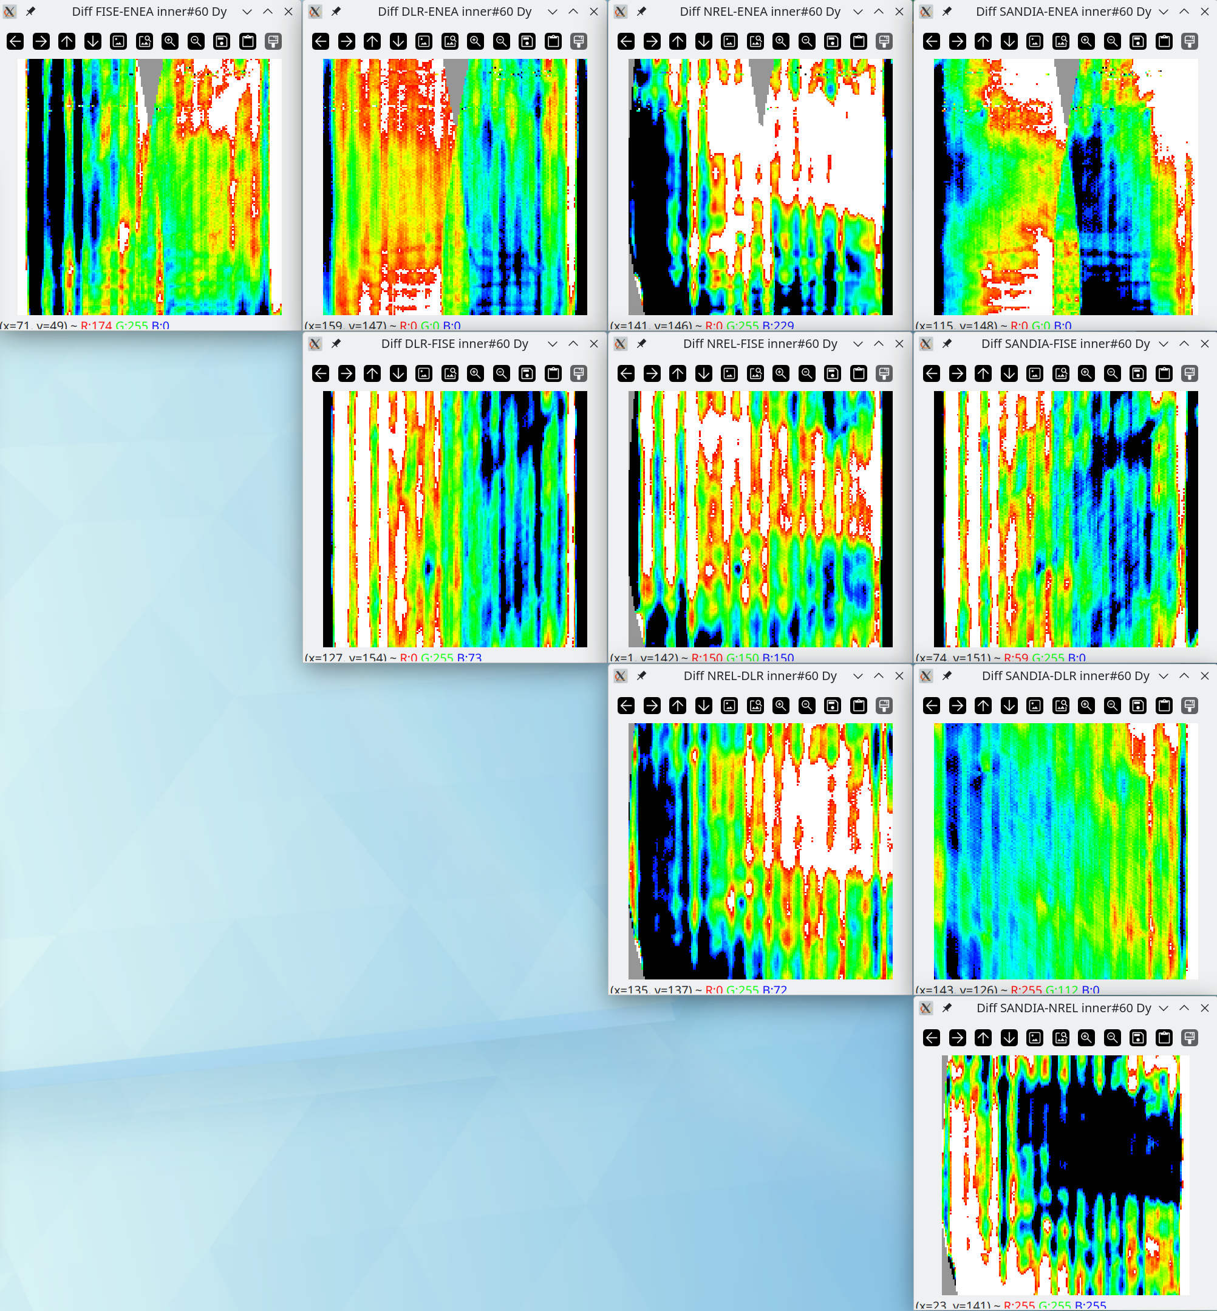

**Difference normalized to 3 sigma for outer#93**

**with internal “2D integration” and “SW realignment by devZ_ideal” options**

Outer#93 Height (z)

|  |  |  |  |  |
| --- | --- | --- | --- | --- |
|  | F-ISE | DLR | NREL | SANDIA |
| ENEA | -0.01 ± 0.06 | -0.05 ± 0.13 | -0.11 ± 0.25 | -0.05 ± 0.10 |
| F-ISE |  | -0.07 ± 0.21 | -0.13 ± 0.30 | -0.06 ± 0.14 |
| DLR |  |  | -0.07 ± 0.23 | 0.00 ± 0.09 |
| NREL |  |  |  | 0.07 ± 0.23 |

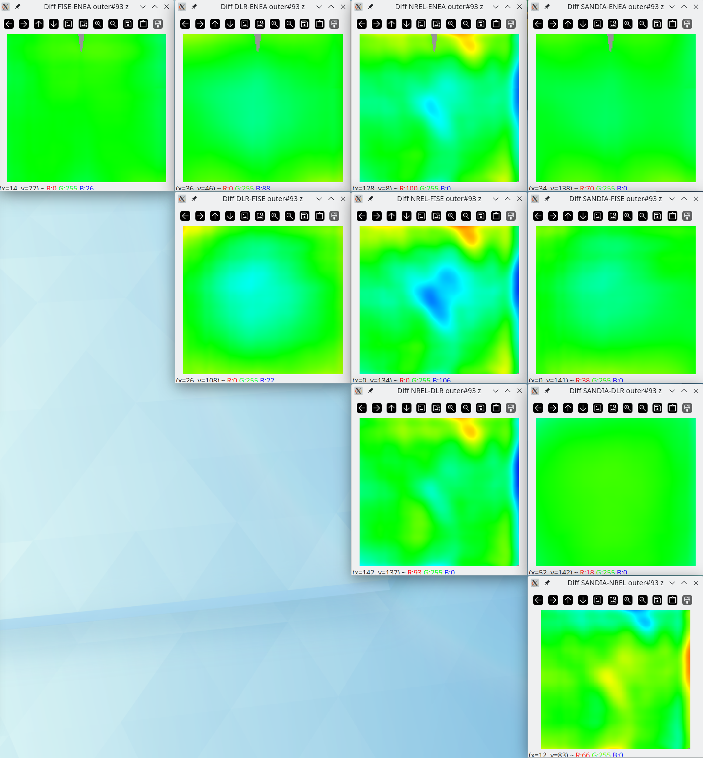

**Difference normalized to 3 sigma for outer#93**

**with internal “2D integration” and “SW realignment by devZ_ideal” options**

Outer#93 SlopeX

|  |  |  |  |  |
| --- | --- | --- | --- | --- |
|  | F-ISE | DLR | NREL | SANDIA |
| ENEA | 0.02 ± 0.28 | -0.04 ± 0.91 | 0.93 ± 2.57 | -0.22 ± 1.17 |
| F-ISE |  | -0.02 ± 0.57 | 0.39 ± 1.07 | -0.09 ± 0.50 |
| DLR |  |  | 0.66 ± 1.51 | -0.08 ± 0.42 |
| NREL |  |  |  | -1.19 ± 2.58 |

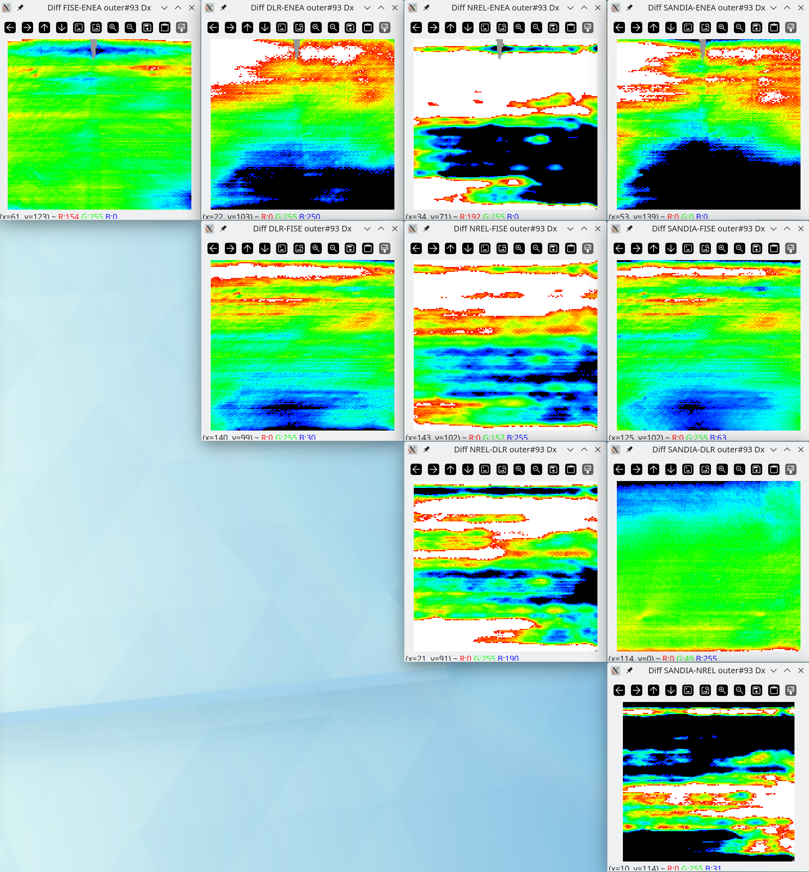

**Difference normalized to 3 sigma for outer#93**

**with internal “2D integration” and “SW realignment by devZ_ideal” options**

Outer#93 SlopeY

|  |  |  |  |  |
| --- | --- | --- | --- | --- |
|  | F-ISE | DLR | NREL | SANDIA |
| ENEA | 0.22 ± 0.83 | -0.01 ± 0.65 | 0.74 ± 3.84 | 0.14 ± 1.29 |
| F-ISE |  | -0.15 ± 0.85 | 0.30 ± 2.34 | -0.16 ± 1.07 |
| DLR |  |  | 0.46 ± 2.56 | 0.07 ± 0.68 |
| NREL |  |  |  | -0.60 ± 3.49 |

